Monitoring Task
Task Description:
Install Prometheus and Grafana on a Linux EC2 machine, connect Prometheus to Grafana, and create a dashboard to view metrics.
Launched EC2:
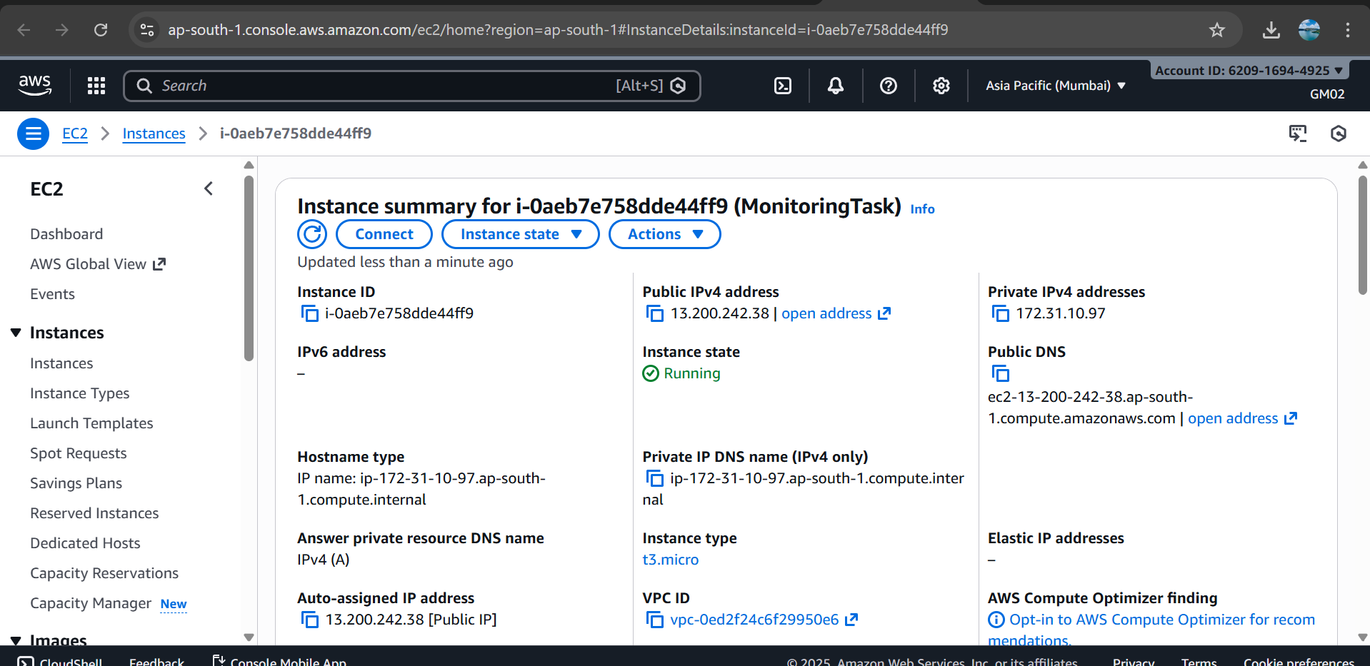
Installed node exporter:
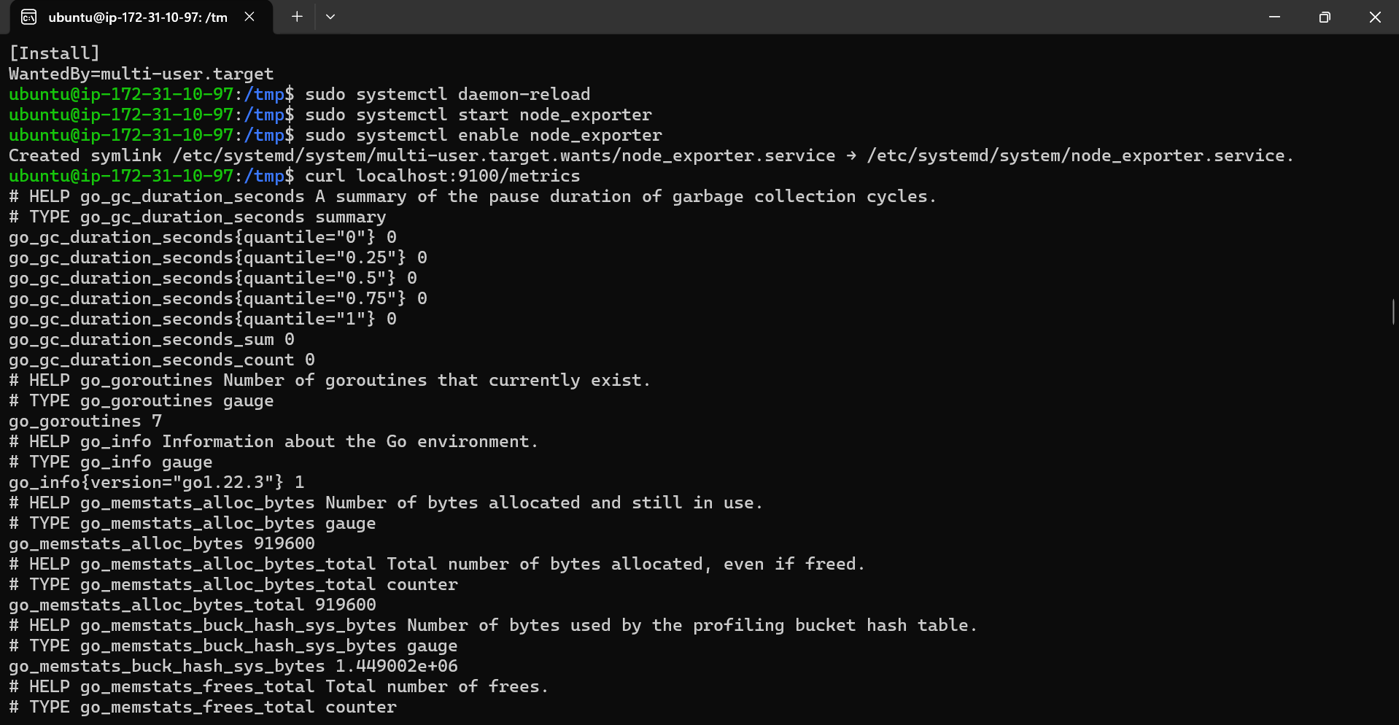
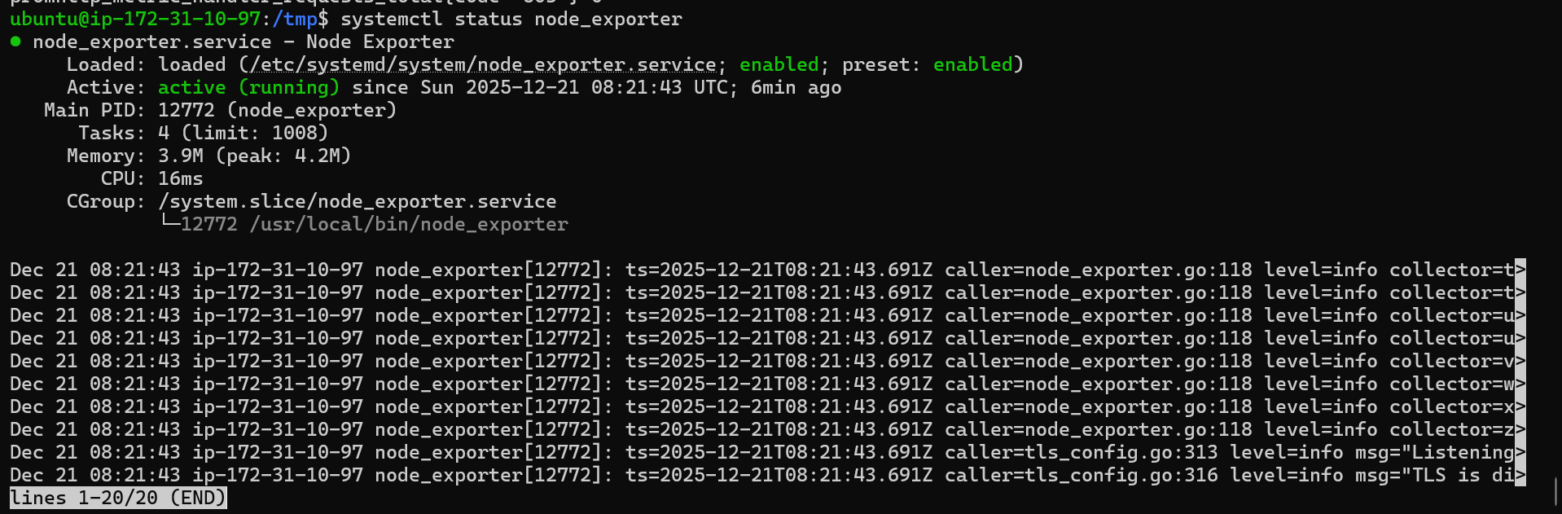
Installed Prometheus and verified the connection
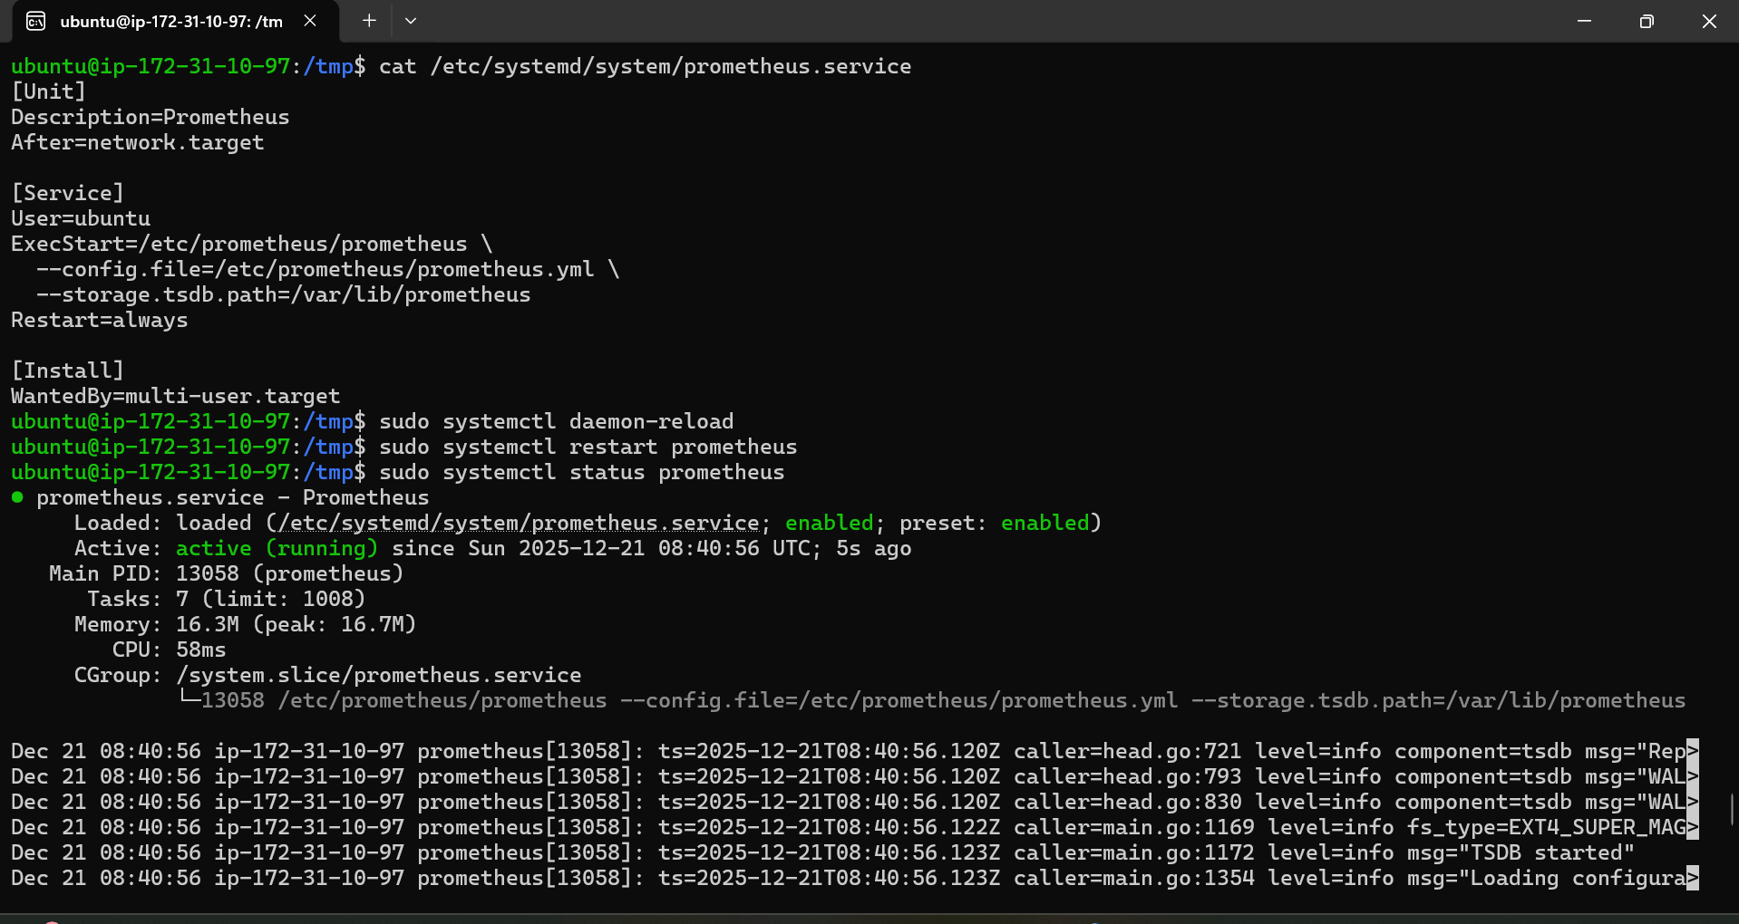
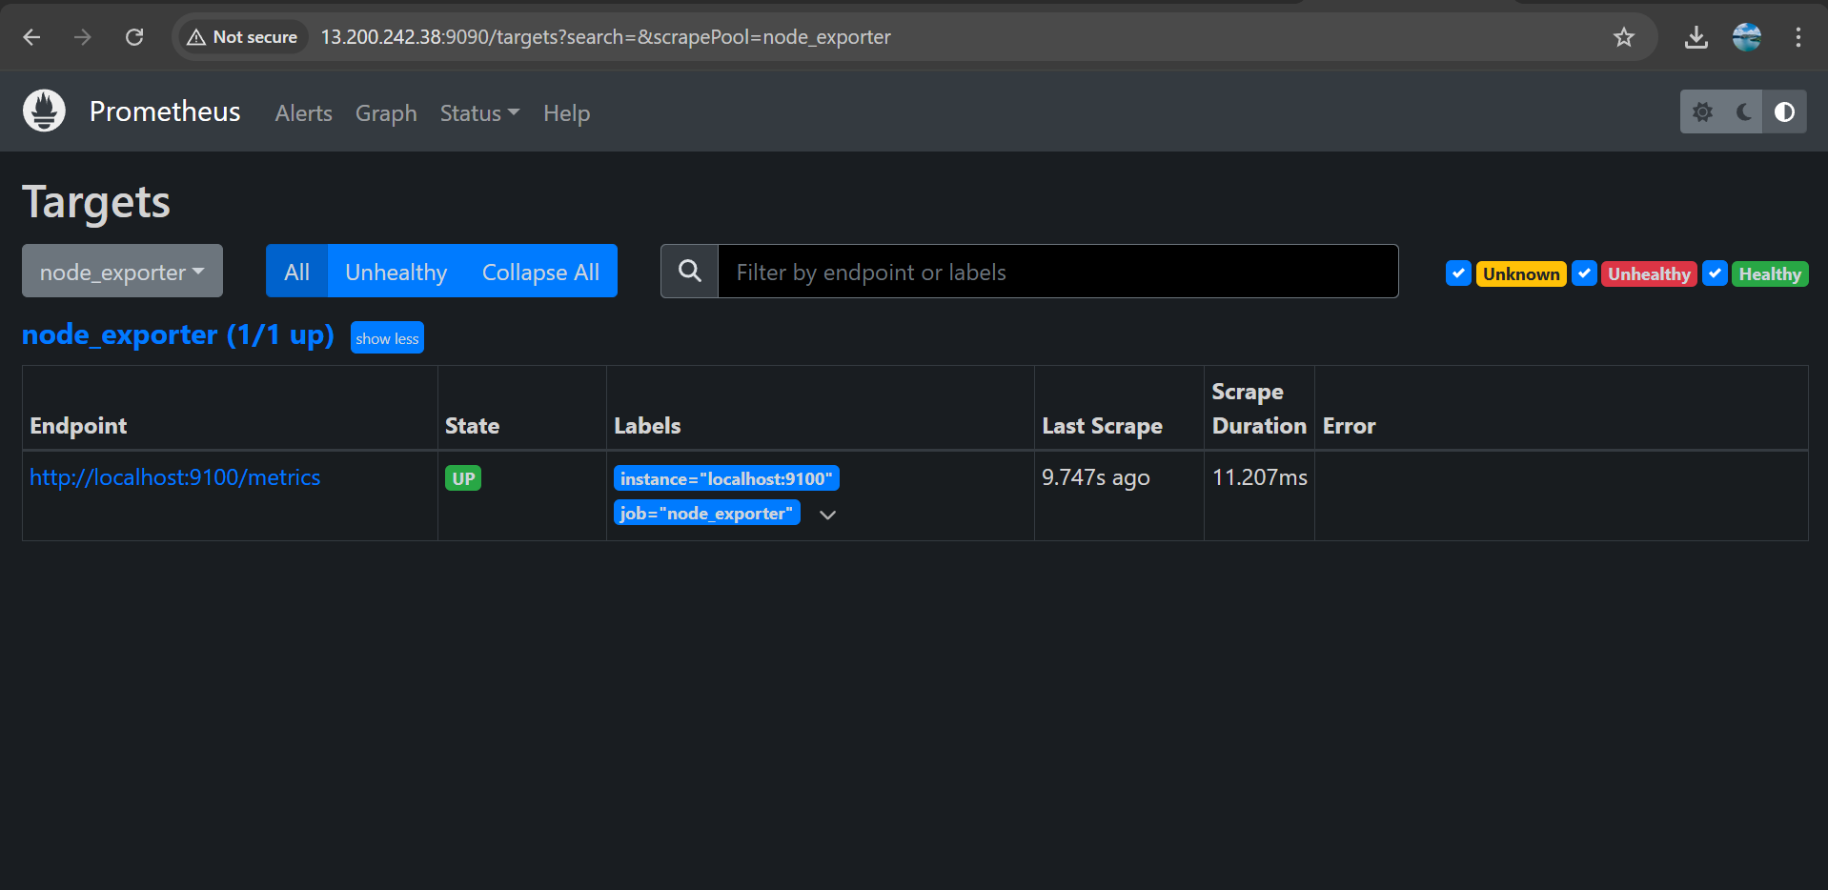
Installed Grafana and connected Prometheus to Grafana and created the dashboard:
